Sed Lab

1. Change the name Jo to Josephine
   * Code: **sed s/Jo/Josphine/g SedLab**
   * Screenshot: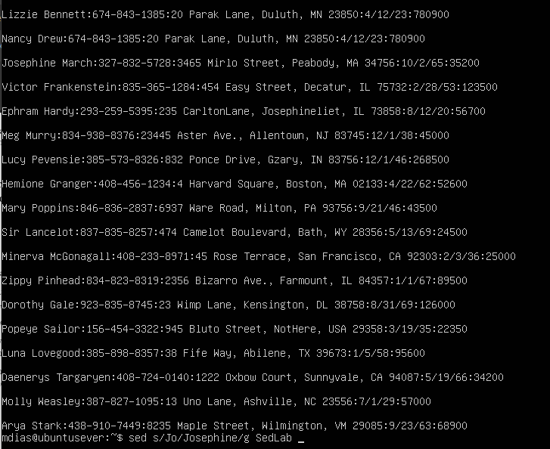
   * Explanation: Using the ‘s’ will substitute Jo for Josephine and then ‘g’ is used to find all the Jo’s in the file and to make sure they all change to Josephine
2. Delete the last 5 lines.
   * Code: **sed ’45,$d’ SedLab**
   * Screenshot:
   * 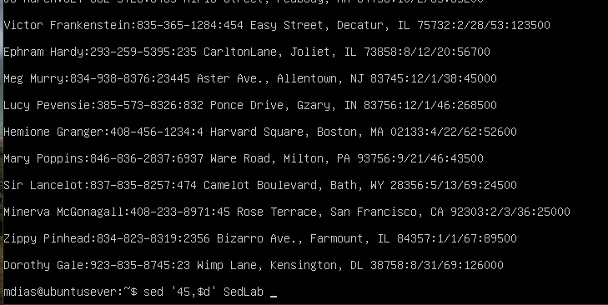
   * Explanation: Line 45 is the 5th line from the bottom. We use $ for to the last line and ‘d’ to delete.
3. Print lines 3-15.
   * Code: **sed -n ‘3,15p’ SedLab**
   * Screenshot: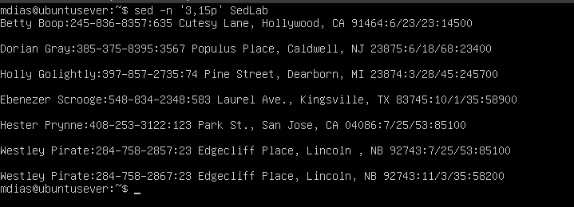
   * Explanation: This command runs very similar to the last. We are using 3 and 15 to give a range and ‘p’ to print the result.
4. Delete lines for people who live in California.
   * Code: **sed ‘/CA/d’ SedLab**
   * Screenshot: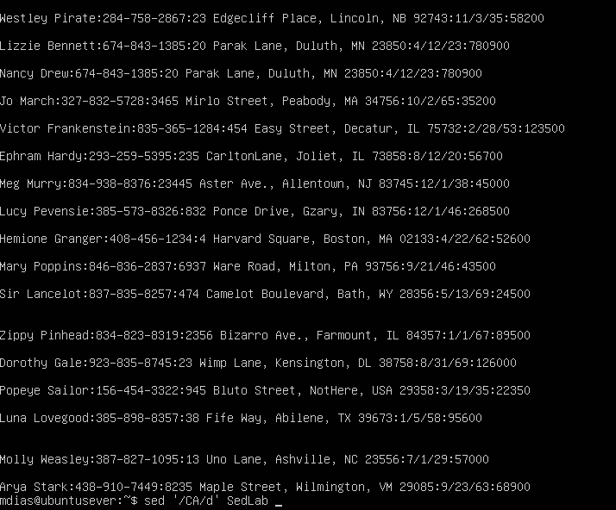
   * Explanation: Using sed since we are deleting lines for those in California, I had to use CA. Then using ‘d’ to signify to delete the line.
5. Print all lines where the birthdays are in the first week of the month. Be careful of the dates for birthdays, the format is MM/DD/YY
   * Code: **sed -n ‘/[0-9]\/[1-7]\/[0-9]/p’ SedLab**
   * Screenshot: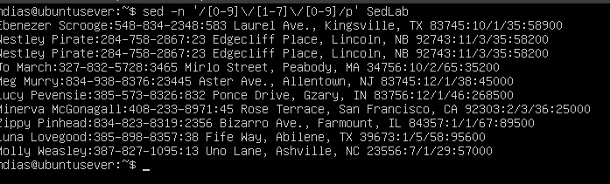
   * Explanation: For this question I first had to use -n so I could suppress default behavior. I begin by giving a range ‘[0-9]’ followed by a ‘\’. The ‘\’ is used as a delimiter so that the ‘/’ in the birthdays is read as a literal slash and not as a special character. Next, we are looking for a birthday in the first week so I created a range of ‘[1-7]’ to ensure we only get results for birthdays in the first week. Once again, we use our delimiter plus a slash and end it with another range of ‘[0-9]’ for the year. To top it off we use ‘p’ to print the lines.
6. Append three asterisks (*) to the end of lines starting with Sir.
   * Code: **sed ‘/Sir/ s/$/***/’ SedLab**
   * Screenshot: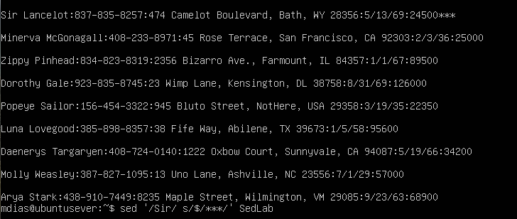
   * Explanation: Sir is used the locate the line we are changing. ‘S’ is used to substitute and ‘$’ is for the end of the line, ‘***’ asterisks.
7. Replace the line containing ”Westley Pirate” with the phrase” As you wish.” Make sure you replace the whole line, not just the name.
   * Code: **sed /Westley Pirate/s/.*/As you wish/’ SedLab > PirateWish**
   * Screenshot: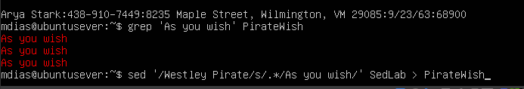
   * Explanation: Using sed we are finding all lines containing Westley Pirate. We then use ‘s/.*/’ to replace the entire line. ‘S’ is used to substitute while using the regular expression ‘.*’ to signal we want to entire line to be replaced rather than just the portion contain Westley Pirate.
8. Change Minerva McGonagall’s birthday to 10/04/1935. Assume you don’t know Minerva’s original birthday. Use a regular expression to search for it.
   * Code: **sed ‘/Minerva McGonagall/s,[0-9]\+/[0-9]\+/[0-9]\+,10/04/1935,’ SedLab**
   * Screenshot: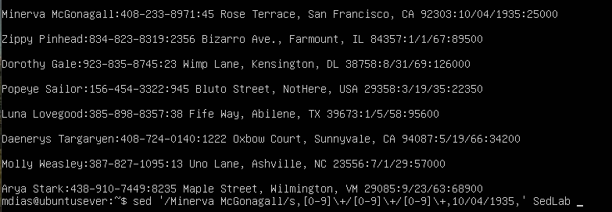
   * Explanation: We are using sed here because we want to find the line containing Minerva McGonagall that we want to change. We then use the character ‘s’ to substitute followed by what we wanted substituted which is a date. For the date you can see we used the ranges of ‘[0-9]’. We also used two delimiters here ‘,’ and ‘+’ instead of just using ‘/’ to make this simpler to find a date in the line. Once we have given the range of the dates we are hoping to substitute we then enter the new date to be subbed in under Minerva McGonagall’s line (10/04/1935).
9. Delete all blank lines.
   * Code: **sed ‘/^$/d’ SedLab**
   * Screenshot: 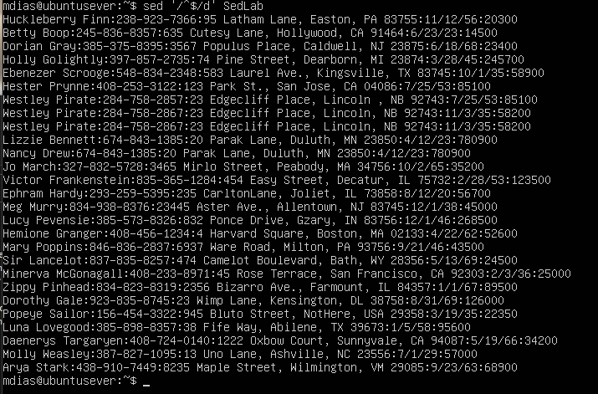
   * Explanation: ^ is used to say we want the lines that begin and end with blank space and $ is used to delete
10. Write a sed script that will (actual sed script, NOT just the commands on the command line) (a) Insert above the first line the title- Great Literary Characters-.

(b) Print the contents of the file, but instead of the phone number starting with an area code, have it start with a 1+, then include the area code and number. For example, (603)123-1234 would turn into 1+(603)123-1234.

(c) Append at the end of the file ”Happily Ever after. The End”

* + Code:

**1i\ Great Literary Characters**

**s/\([0-9]\{3\}\)/+1(%)\1/**

**$a\ Happily Ever After. The End.**

* + 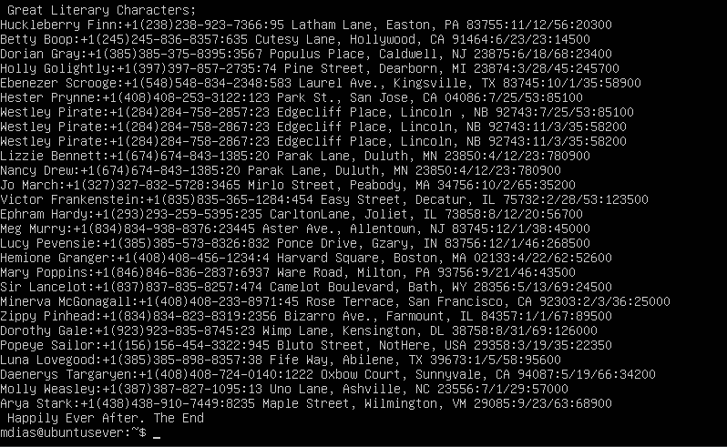A screenshot of a computer

    Description automatically generated
  + Explanation:
    1. **1i\ Great Literary Characters :** 1 is used to signify the first line which is where we want it added and ‘I’ is used to insert text above that line
    2. **s/\([0-9]\{3\}\)/+1(%)\1/ :** ‘s’ is used to substitute we then have it recognizing the 3 consecutive numbers range of 0-9. Next, we are adding +1 at the start of the phone number. I also added parathesis’ around the area code to make it easier to read.
    3. **$a\ Happily Ever After. The End. :** $a is used to append below the last line and add the text